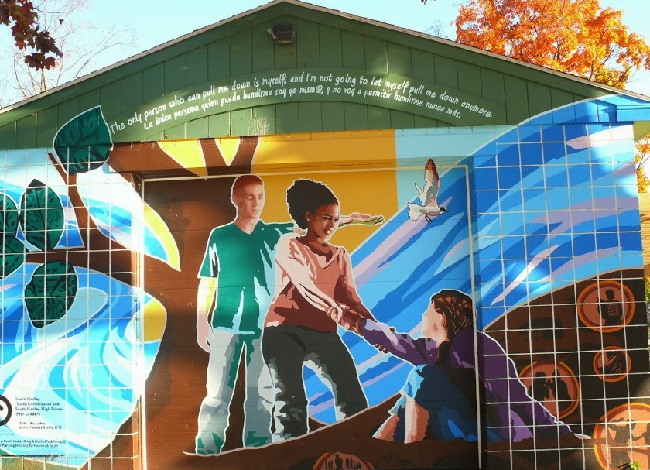
South Hadley Drug & Alcohol Prevention Coalition
est.2005
______________________________________________________
Meeting Minutes
Wednesday, November 14, 2017 4pm—7pm Mt Holyoke College Willits-Hallowell Center

Sector Representatives Present: Greg Petrosky (Medical); Steve Fleming (Law Enforcement); Luke Petrosky (Youth); Denise Kelly-Lachat (Parent); Beth Winfield (School); David Sullivan (State or Local Government); Heather Warner (Other Agency involved in Reducing Youth Substance Use); Dan Pease (Media); Walter Morse (Civic Group); Sr. Cathy Ormond (Faith Community)
Coalition Partners Present: Tom O’Neil; Angie LeBel; Dante Pio; Grant Petrosky; Andrew Couture; Reuel Colon; Taylor Gelinas; Cailyn Bolduc; Jillian Whalen; Marie Millane-Schosstein; Sarah Smith; Susan Cook; Dianna Goldberg; Robin Taugher; Karen Jacobus; Jennifer Balut; Deborah Mendes; Rev. Lori Souder; Fr. Michael Twohig; Patricia Monroe; David McClelland; Walter Hamilton; Eleanor Small; Jeff Stone; Jody Hensley; Michael Knapik; John Hine; Michael Sullivan; Tom Mitchell; Cherry Sullivan; Rick Pio; Ira Brezinsky
Coalition Staff Present: KWP, Tina Lukasik

Topic | Action to be Taken/Decision to be Made | Who is responsible*
Welcome  Coalition Highlights  Guest Speaker  Data Presentation  Guest Speaker  Closing & Thanks | Introductions.  Housekeeping Issues (Sign-in; name tags; rest rooms; etc.)  Youth Presentation by Peer Leaders (Present and Past)  Acknowledgements of contributions by key stakeholders including for SBIRT: nurses Elieen Garvey, Sarah Smith & Beth Winfield; Life Skills Education: Sue Cook & Dianna Goldberg; Community presentations from the faith community: Sr. Cathy, Rev. Lori & Fr. Michael; support for town by-laws by the Board of Health: Sharon Hart & our town Administrators John Hine, Ira Brezinsky and Michael Sullivan; Narcan training & support: Cherry Sullivan; Co-sponsorship of events with Mt Holyoke College: Karen Jacobus & Jen Balut; Middle School Youth Conference & Coalition support: D.A. David Sullivan & Laurie Loisel; Parent Cafes and outreach: Tina Lukasik; Parent involvement: Denise Kelly-Lachat & Marie Millane-Schlosstein; Professional community support: Greg Petrosky & Eleanor Small; Movie & Safety Night, Golf Carts ‘n Goggles and other special events: SRO Steve Fleming; Media Support from our newspapers & cable TV including Dan Pease, Bob Smith & Rick Pio; Community support of many kinds: Walter Morse. Deep appreciation!  Jeff Stone, North Suffolk Public Health Collaborative  Updates on the history and current status of the opiate crisis in Massachusetts  Highlights from the Bach-Harrison Prevention Needs Assessment Survey of Grades 8, 10 and 12 conducted in the Spring 2017  Jody Hensley, Chief Policy Advisor of MA Prevention Alliance  Information from the field concerning social marijuana in MA  GROUP PHOTO  DINNER with small group discussions at the table  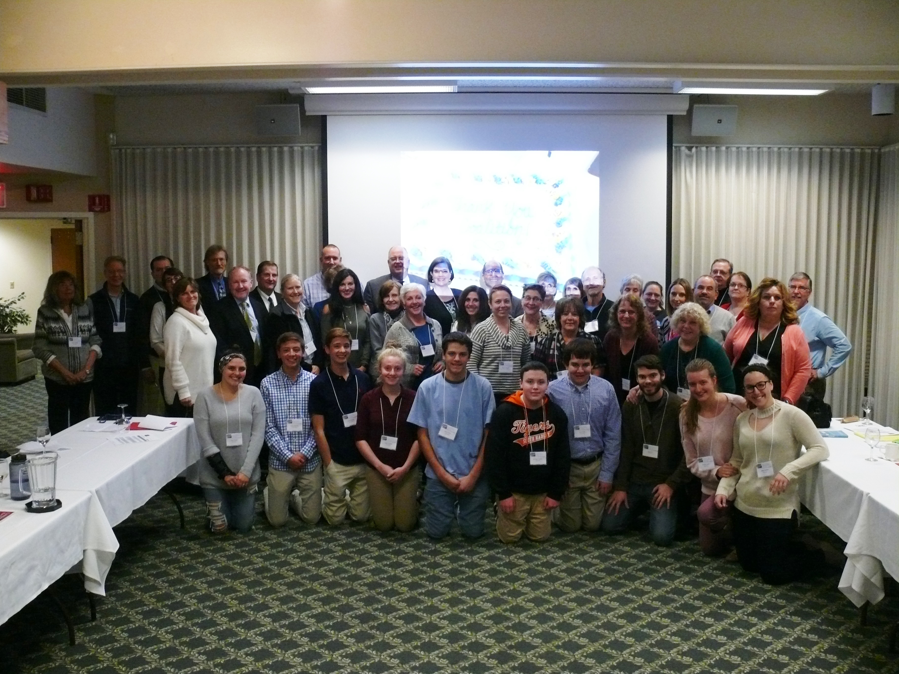 | KWP  Heather Warner  KWP
Coalition Capacity Building | - No Special Projects vote needed at this meeting.  - Congratulations to the Coalition for recognition received by the Office of National Drug Control Policy for its work. Ours was one of three coalitions to be so recognized out of 719 in the US. This information was included in everyone’s welcome folder.  - The meeting room was at capacity!
Reduce Youth Substance Use | - Future Direction: This is the final year of the grant, which means that we need to write for a DFC continuation grant for year 6—10. There will be a day of training on that at the CADCA Conference in February 2018.  - Marijuana Legalization: Town Administrator Mike Sullivan said that he attended a training at SPIFFY to learn about the necessary steps to propose an “opt out” vote in the town of South Hadley. This will be taken up by the Selectboard at their December meeting.  MEETING ADJOURNED AT 7 PM | KWP
Upcoming Meetings/Events
Next Coalition Meeting will be December 13, 2017 at 6:30 pm

