
South Hadley Drug & Alcohol Prevention Coalition
est.2005
______________________________________________________
Meeting Minutes
Wednesday, December 13, 2017 6:30pm—8pm South Hadley High School Library

Sector Representatives Present: Greg Petrosky (Medical); Steve Fleming (Law Enforcement); Tom O’Neil (Youth); Denise Kelly-Lachat (Parent); Vinnie Napoli (School); Laurie Loisel (State or Local Government); Walter Morse (Civic Group).
Coalition Partners Present: Marie Millane-Schosstein; Sonja Sherwood; Beth Winfield.
Coalition Staff Present: KWP, Tina Lukasik

Topic | Action to be Taken/Decision to be Made | Who is responsible*
Welcome | Introductions.  Announcements & Review of recent events:  - October Parent Café: wonderful presentation, very low attendance. Recommend we tie next presentation to an event within a church program. Talking to Sr. Cathy.  - GCC Middle School conference was well-received by the youth.  - Children’s Remembrance Day Vigil: About a dozen people, patio heater helped! Article forthcoming in The Town Reminder.  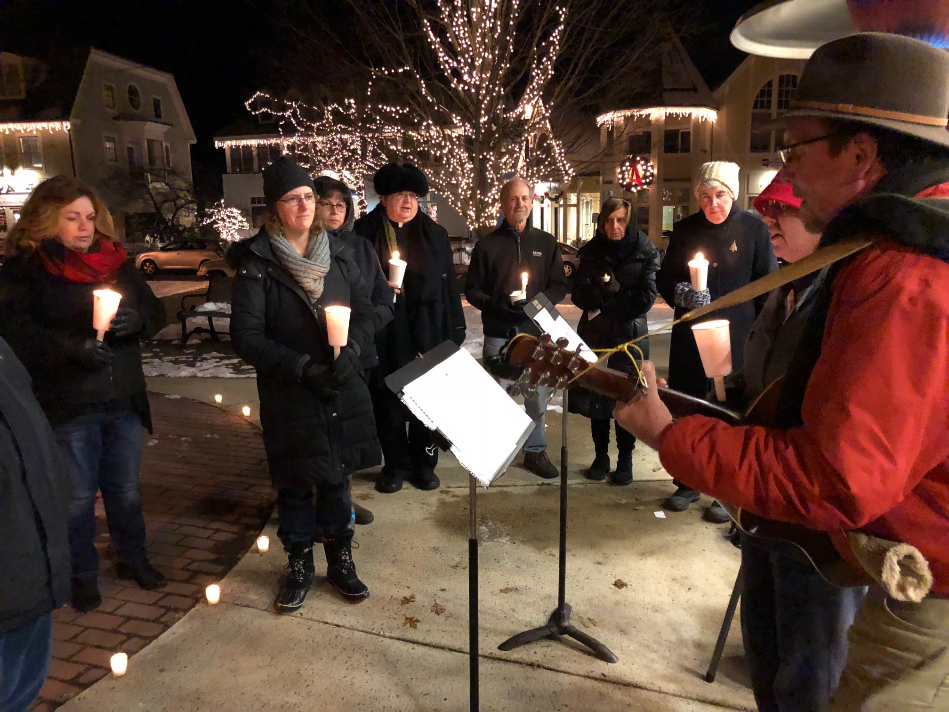 | KWP & Tina
Coalition Capacity Building | - Vote to approve the November minutes. Approved.  - Special Projects vote to appropriate funds from “roll-over” if needed for CADCA coverage so two of the MESMS health teachers can attend. Approved.  - Congratulations to the Coalition for our successful retreat! There were two very nice news articles publicizing this.  - Any member of our Coalition is welcome to attend the SPIFFY Coalition meeting on February 7 from 9 to 11 am at 97 Hawley Street in Northampton. We are a member of that Coalition as well as the Hampshire HOPE Coalition. | Membership  KWP
Reduce Youth Substance Use | - Just e-mail KWP if interested in borrowing the book by Anita Devlin to read.  - Updates from our Selectboard and our Planning Board on Marijuana Legalization: *Town Administrator Mike Sullivan presented to the Selectboard and made a request to propose an “opt out” vote in the town of South Hadley. This was approved by the Selectboard and next goes to Town Meeting at their January meeting.  *Town Planner Richard Harris made a presentation to the Planning Board for regulations on zoning for any commercial marijuana business in the event that there is no ban on these businesses. The regulations he suggested are that no business be allowed within 300 feet of a school, library, church, senior center, day care center, dormitory or residence. This was approved and goes to Town Meeting.  3. Coalition action on Marijuana regs:  * There is still time to e-mail Cannabis Control Commission.  * It would be a great idea to write a Letter to the Editor of The Town Reminder to begin educating the residents about why it is better for youth if we ban commercial sales.  * Next Parent Café should bring a speaker to highlight the issues for parents.  * Greg will ask his fa-in-law about a Loomis House presentation for Seniors.  * KWP will ask Dr. Ruth Potee to come in March for a community presentation.  * Steve Fleming will propose a Student Handbook change to the HS Student Assistance Team (SAT) to include all nicotine products under drug paraphrenalia category with the same consequences. Vaping has become a big problem. Kids vape weed too.  MEETING ADJOURNED AT 8:15 PM | KWP

Upcoming Meetings/Events

Next Coalition Meeting will be January 10, 2017 at 6:30 pm
Bag The Community is coming over the MLK weekend.
The Winter Cotillion is also coming in January!

Visit our website at www.southhadleyprevents.org
And visit our Facebook page! 

The mission of the South Hadley Prevention Coalition is to collaboratively initiate, coordinate and sustain prevention & intervention efforts that reduce youth substance use within the town of South Hadley.

15 Newton Street *South Hadley MA 0105* 413.5506 ext.3612 * kwalshpio@shshools.com

